Line Coding

Geopak - Assuming you know how to import an ASCII file into Geopak, here are the settings to get the line coding to work.

1. Set the “Delimiter” to a comma(,) and the “Comment Delimiter” to a semicolom(;).
2. Select the Pnum, Y, X, Z and then select PCode for the fifth field. At that point, a box appears under the Z & PCode boxes. Select “Link w/No Gap (LF)”.

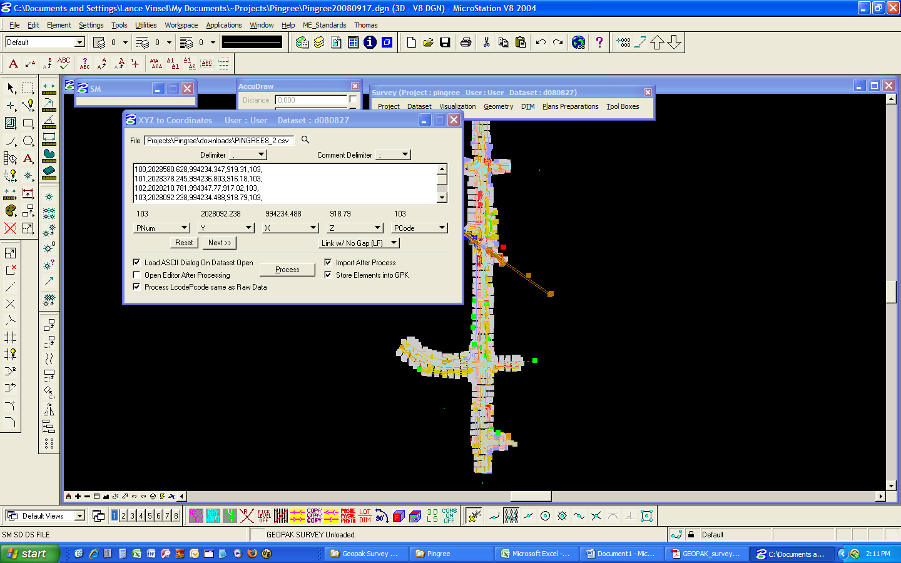

1. Select the “Next>>” button and select Lcode for the sixth field selection. The “Link w/No Gap (LF)” box disappears and the “Linking Code” box appears above linking codes. Select the “Linking Code” and set them as below.
2. Geopak allows the use of any character to control line coding. I use non-alpha – non-numeric characters, because they are easy to parse (find/replace) if you want to remove them or manipulate them.

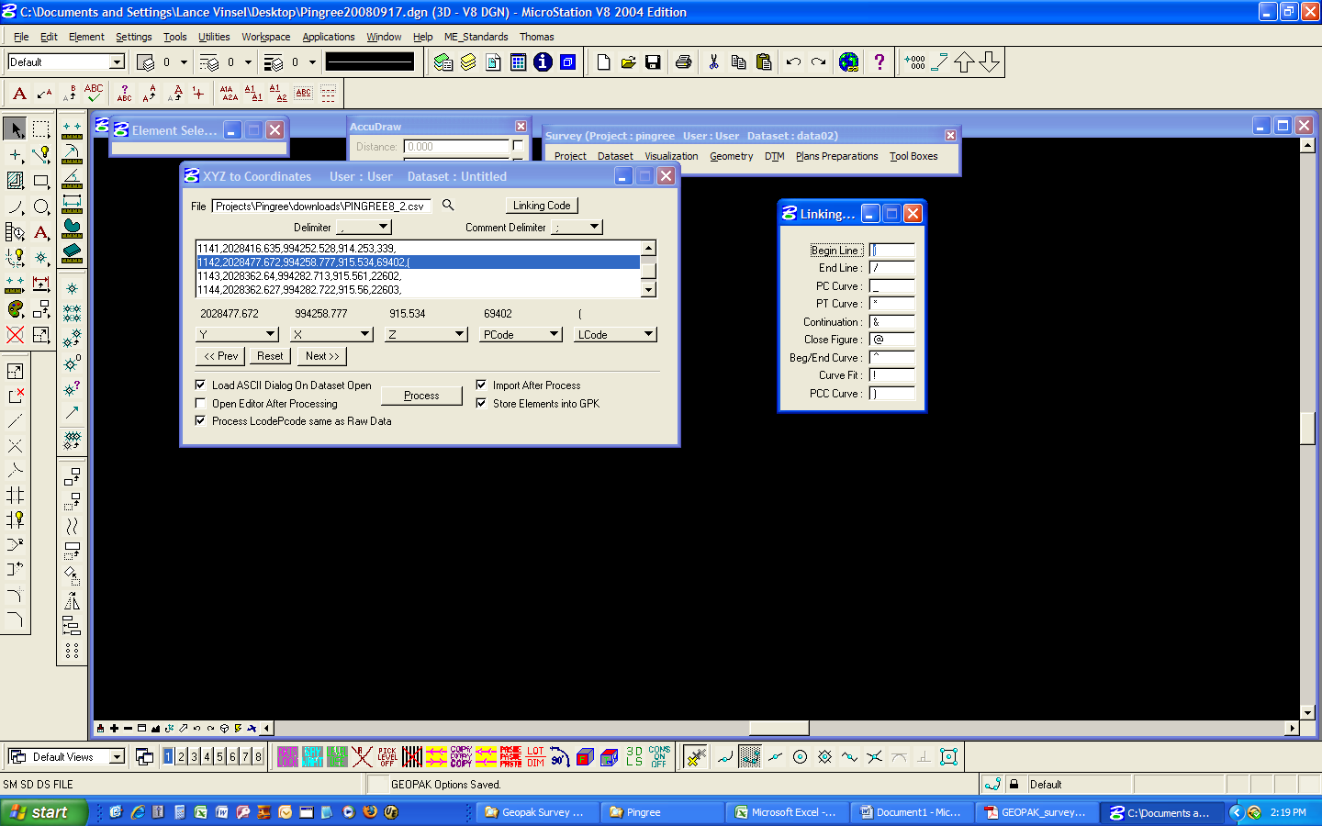

1. These are the codes that I use, AS THEY INPUT INTO THE DATA COLLECTOR. OMIT THE COMMAS IN THE GEOPAK “LINKING CODE” BOXES, as in the above screen capture:

|  |  |
| --- | --- |
| Begin | ,( |
| PC | ,_ |
| PT | ,*& |
| Beg/end curve | ,^ |
| Close | ,@ |
| Continue | ,& |
| Curve fit | ,! |
| End line | ,/ |
| PCC curve | ,) |

1. Creating curves with GEOPAK line coding is a little tricky. To ***CORRECTLY***  draw the curve there must be a piece of tangent before the PC and after the PT. These do not have to be long, a one foot piece should do it. But, if it doesn’t have these it will not draw the curve correctly.